

|  |
| --- |
| Coursera Capstone Project  NYC Restaurant Location Analysis |
|  |
| July 18, 2020  Authored by: Michael Iannacci |

Week 1

|  |
| --- |
| **Introduction/Business Problem** **Background**  A group of investors is looking to invest in a new restaurant concept and select a location in New York City to establish their first location. It is vital to the investment group that this location is successful and acts as a model location for future locations and potential franchises.  Given that New York City is the most populous city in the United States with an estimated 2019 population of 8,336,817 distributed over about 302.6 square miles, it would be the ideal location to establish the first 10 locations over time before expanding throughout the region.  A member of the group has some general awareness of data science and knows that it is a powerful tool that can be used to help his group make the best decision possible for the location of the initial launch. He has convinced his team to hire me as a data scientist to run an analysis to guide their decision making process.  The type of restaurant that the group wants to create has a niche target of active people who are trying to eat healthy. Their concept combines both a grab-and-go section as well as a sit down section. Their primary focus will be health food and smoothies that will appeal to the active members of the community. They will also offer some traditional fare in order to have options to capture a wider customer base. The overall strategy is to strategically locate their restaurant around venues that their target consumer is most likely to frequent such as gyms, pools, yoga studios, etc.  After initial brainstorming session with members of the investment group, we developed a list of comprehensive venues to target in a given locale. A restaurant location strategically placed near as many of these venues as possible will maximize the foot traffic to the restaurant. Because the success of the restaurant depends on this foot traffic, I recommended that we also take a look at the crime rate and take that into consideration when the ultimate location is selected.  **Business Problem**  After a second meeting, the requirements of the analysis were finalized:   1. Location will be in one of the 5 boroughs of New York City 2. Location will be centrally located near as many of the identified target athletic/fitness venues as possible 3. Location should minimize the proximity to existing competitors 4. Location should not be in a high crime area in order to promote foot traffic  * After further discussion, it was agreed that only felonies in the latest calendar year of available data will be considered.  **Data** The following data will be used for this analysis:   1. The city of New York will be analyzed for this study. New York City is comprised of 5 boroughs: Manhattan, Brooklyn, Queens, the Bronx and Staten Island. There are a total of 306 neighborhoods in these 5 boroughs. In order to analyze these neighborhoods, the free dataset at <https://geo.nyu.edu/catalog/nyu_2451_34572> will be used. This dataset contains information, including latitude and longitude coordinates, which will allow for the boroughs and neighborhoods to be segmented and explored. 2. New York City geographical coordinates data will be used as input for Foursquare API. This will allow for venues within each neighborhood to be explored and classified. 3. New York City crime data will be used from Kaggle at <https://www.kaggle.com/adamschroeder/crimes-new-york-city> . Only data for felony crimes over the full 2015 calendar year was extracted and will be used to give an overall picture of high and low crime areas. 4. Wikipedia will be used for miscellaneous information and data   <https://en.wikipedia.org/wiki/New_York_City> |

## **Methodology**

The ultimate goal of this project is to provide the client with the necessary tools and information to select the ideal initial location to launch their new restaurant concept and then to subsequently select additional locations for expansion.

The 5 boroughs of New York City (Brooklyn, The Bronx, Manhattan, Queens and Staten Island) and the 306 neighborhoods contained within, were explored.

The Exploratory Data Analysis began by utilizing the newyork_data_json file to create a pandas dataframe containing the geographical coordinates of the NYC neighborhoods. Figure 1 shows the locations of all the neighborhoods in NYC.

Figure 1: NYC Neighborhoods

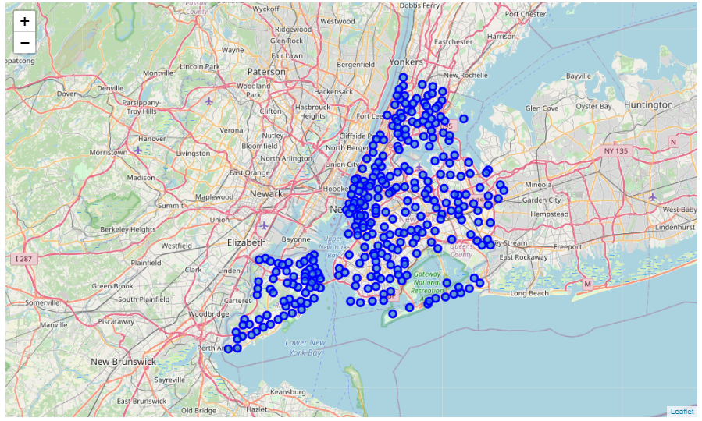

The map in Figure 1 was created sing geopy and folium to overlay the location of each neighborhood on top of a map of NYC.

In order to narrow down the search area, NYC demographics data was obtained from Wikipedia at <https://en.wikipedia.org/wiki/Demographics_of_New_York_City>. This data was scrapped and parsed using BeautifulSoup. A table was created with a breakdown of the data by borough. The population, land area and population density was examined for each borough. The data is summarized in Table 1.

Table1: NYC Demographic Data by Borough

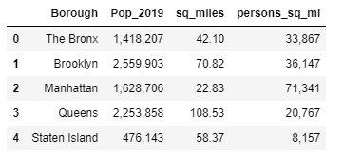

An examination of this data shows that, in order to maximize foot traffic and exposure for the restaurant, it should be located somewhere in Manhattan.

The next step of the analysis was to take crime data into consideration. A full calendar year’s worth of data was obtained for NYC from kraggle.com at <https://www.kaggle.com/adamschroeder/crimes-new-york-city>. Due to the incredibly large volume of data, the file was cleaned to only look at felonies. The resulting data describes the date of the crime, what kind of crime was perpetrated, which borough in which it occurred, the address and the coordinates. The resulting data file is still very large but it is a manageable tool for the client to use once they have a specific location that they are considering. Once the coordinates of the potential location are known, the tool can be used to plot the crimes within a certain radius of the location to see if crime is a particular concern.

Based on the both the crime and demographic data, it was strongly recommended to the client that they should focus on a Manhattan location. Thus, the remainder of this analysis will focus on Manhattan. Figure 2 shows the location of all of the Manhattan neighborhoods that will be considered.

Figure 2: Manhattan Neighborhoods

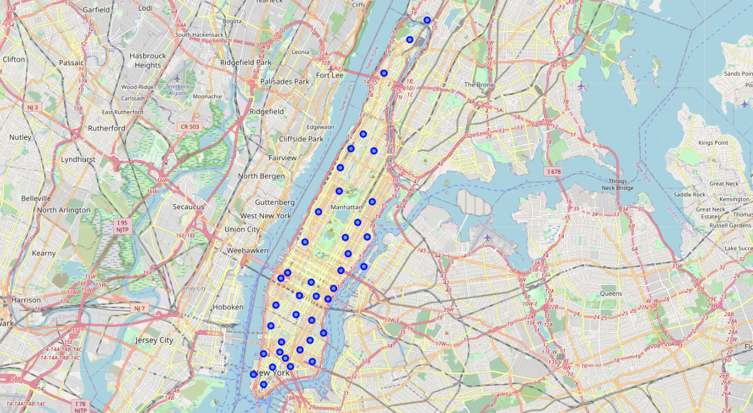

These Manhattan neighborhoods were then explored in more detail utilizing the Foursquare API. Using the geographical coordinates of each neighborhood, the top 100 venues in a radius of 500 meters were obtained by making Foursquare API calls.

The neighborhoods were then grouped into clusters based on based on the mean occurrence of venue categories. Clustering was performed using a K-means algorithm. The resulting clusters are pictured in Figure 3. This information will be useful to the client for future expansion allowing them to select a similar neighborhood If the first was successful, or try a different one if they are looking for improvement.

Figure 3: Manhattan Neighborhoods Clusters

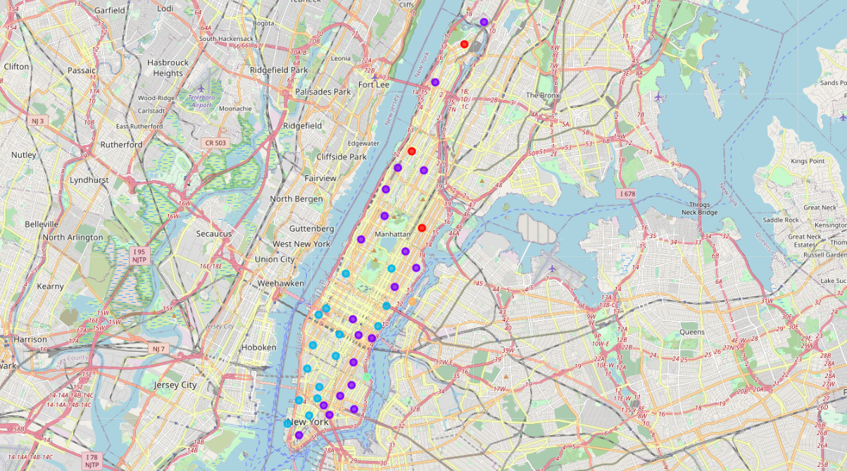

The final step of the analysis is to look at the venues that the customer established as

Locations they would like to be located near as well as competitors that they wanted to distance themselves from. Table 2 shows a list of target venues and Table 3 shows a list of competitors to avoid.

Table 2: Target Venue Types



Table 3: Competitor Venues



The location of these two sets of venues were plotted to show which areas the client should target (Figure 4) and which they should avoid (Figure 5).

Figure 4: Target Areas

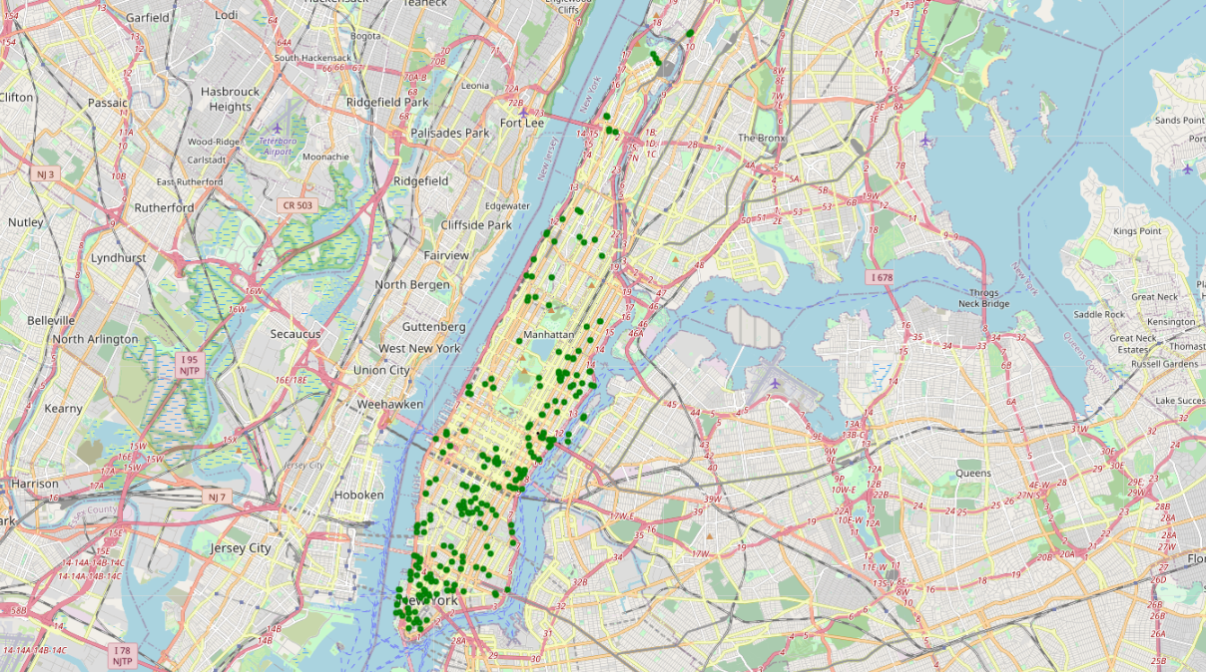

Figure 5: Areas to Avoid

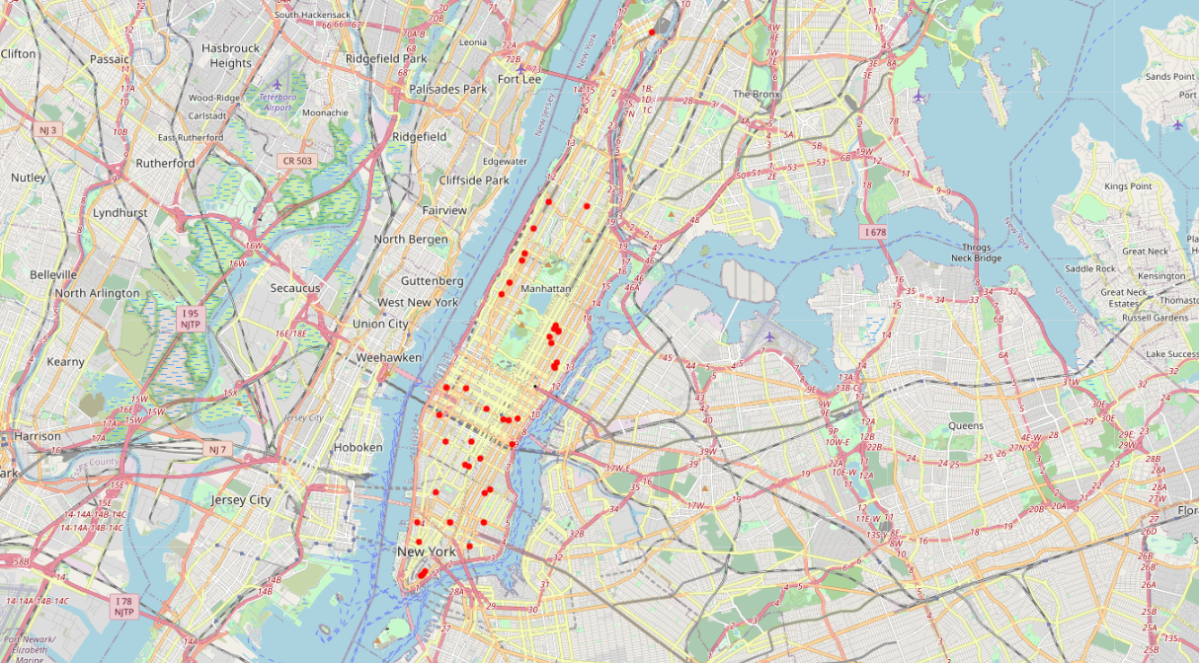

## **Results**

The data analysis described in the Methodology section developed the required tools to make an informed decision about where to focus the search for the initial location of the restaurant.

A detailed breakdown of the demographics and crime data identified the borough of Manhattan as the primary search locations. The maps provided in Figures 4 and 5 show which areas should be targeted and those which have direct competitors that should be avoided.

This information should allow potential real estate to be targeted for purchase or lease. It is recommended that once these potential locations are identified, the crime data should be consulted to determine the relative safety of the area.

## **Discussion**

This analysis incorporated a data set that should be updated periodically as the expansion plans for the restaurant develop. In particular, gyms have a rate of closure higher than other businesses. Likewise, some of the competitor venues may be more of a trend or niche and could also experience higher closures. Thus, the venue information obtained from Foursquare should not be considered static and should be re-examined prior to making a decision about the next location to be opened. The result will be updated and more accurate Target Area and Areas to Avoid maps (Figures 4 and 5 above).

The demographic information should not require updates as the borough of Manhattan will always be the most densely populated of the five boroughs. Therefore, based on the data presented in the analysis the neighborhoods in Manhattan should be the focal for the first several locations before expanding out to the other 4 boroughs. This will allow for the most foot traffic as well as a wider exposure for the restaurant and allow for word of mouth advertising.

Finally, as explained in the analysis, the crime data will only be useful once the coordinates of a potential location are known. With that information available, the crime data can then be assessed within a specified radius to determine if there is a major concern.

## **Conclusion**

In this study, the geographical, demographic, crime rate and venue information were examined for New York City and tools and recommendations were generated to guide and assist the client with the selection of their initial restaurant location. Libraries such as numpy, pandas, json, geopy, matplotlib, folium, csv, BeautifulSoup and Foursquare API calls were used to explore, locate, tabulate, and cluster the data into meaningful maps and tables that the client could both interpret and utilize.

Based on the criteria gathered from discussions with the client, it was decided that the initial locations would focus on Manhattan neighborhoods. The venue data was sorted and grouped to establish both Target Areas and Areas to Avoid due to the existence of competitors.

The clustering of neighborhoods will also allow the client to select either a similar or different type of neighborhood when planning its expansion. Thus, this analysis can be leveraged for expansion with the caution that venue data should be updated each time.